Reducing Stockouts and Order Hold Losses through Sales Analysis for a Fashion Jewellery Retailer
A Mid-term Submission Report for the BDM Capstone Project
Submitted by
Name: Ritoma Nandi
Roll number: 23f3001843


IITM Online BS Degree Programme,
Indian Institute of Technology, Madras, Chennai
Tamil Nadu, India, 600036

Contents
1 Executive Summary 2
2 Proof of Originality 2
3 Metadata 2
Sheet 1: Invoices 3
Sheet 2: Daily Sales 3
Sheet 3: Product Summary 3
4 Descriptive Statistics 3
Table 1: Category-Level Descriptive Statistics 4
Table 2: Monthly Revenue Descriptive Statistics 4
Table 3: Top 10 Products by Revenue 4
Insights from Descriptive Statistics: 4
5 Detailed Explanation of Analysis Process/Method 4
Introduction 4
Objectives 5
Objective 1: Sales and Inventory Performance Analysis 5
Objective 2: Unconfirmed Order Hold Management 5
Pre-Processing of the Data 5
Step 1: Manual Data Entry 6
Step 2: Flattening the Data 6
Step 3: Building the Product Summary 6
Step 4: Data Cleaning 6
Justification for Descriptive Analysis 7
Analysis Tools 7
6 Results and Findings 7
Finding 1: Bracelets and Earrings Dominate Revenue 8
Finding 2: Revenue is Growing Strongly Month on Month 8
Finding 3: A Small Set of Products Drive Most Sales 9
Finding 4: Units Sold by Category Shows Earrings Lead in Volume 9
Summary of Key Patterns 10
Pattern 1: Volume vs Value split 10
Pattern 2: Accelerating growth 10
Pattern 3: SKU concentration 10
Status of Objective 2 10
Note on Additional Business Need Raised by Owner 10

1 Executive Summary
Zane Lifestyle is a Kolkata based company that deals with fashion accessories and jewellery under the brand Vanki. It is a B2C retailer of fashion accessories and jewellery run as a one outlet microenterprise by the founders. Products include anti-tarnish earrings, bracelets, necklaces and rings available for sale physically as well as through WhatsApp and Facebook. Product delivery is done through India Post and DTDC.
The two main business problems observed are lack of a digital inventory system and poor tracking of sales. These two issues combined put the company at a higher risk of excess inventory of slow movers as well as stockouts of fast movers, especially during certain seasons like Durga Puja and wedding seasons.
In order to resolve these problems, primary data was collected directly from the business in the form of 100 orders (ORD001 – ORD100) and 200+ line items. The data collected includes order number, date, product name, category, quantity sold, unit price, order total, payment mode and return status. This information was obtained manually through physical invoices and social media chats and then recorded on Microsoft Excel in a flat-file structure.
Preliminary descriptive analysis reveals that Earrings and Bracelets dominate order volume, UPI is the overwhelmingly preferred payment mode, and May shows a notable uptick in both order frequency and average order value compared to March (May being the peak wedding season). These findings lay the groundwork for ABC classification and Pareto analysis, which will yield actionable inventory and stocking recommendations.

2 Proof of Originality
Letter from Organisation:
https://drive.google.com/file/d/1m5-a8QPbRP_wEB9t7aiSZEimXmlwv9Hp/view?usp=drive_link
Shop Images:
This folder contains images of the shop outside and inside https://drive.google.com/drive/folders/1NoNgMU6sRJ9ZR-xjPkaV1quxmNEo7jgQ?usp=sharing
Video interaction (2nd meeting):
The link attached is the recording of the second meeting done with Founder of Zane Lifestyle on 17th June: https://drive.google.com/file/d/1xZROMHnyXsWV1HyC7zVTSSRA45D3lZ71/view?usp=sharing
Social Media account of Organisation:
Facebook Account: https://www.facebook.com/share/14gvyyQtiqF/
WhatsApp Number: +91 81004 85981

3 Metadata
The datasheet used for this project is titled Jewelry_Orders_Cleaned.xlsx and contains three worksheets: Invoices, Daily Sales, and Product Summary. Together, they capture all transaction data collected from Zane Lifestyle (brand: Vanki) over the three-month period of March to May 2026.
Dataset Link: https://docs.google.com/spreadsheets/d/1uSjFrRDbJUNsFOiAyagPsGz0Pd2pZ5sF/edit?usp=sharing&ouid=101189696649092181254&rtpof=true&sd=true

Sheet 1: Invoices
Column | Description | Relevance to Problem
Order No. | Unique identifier for each transaction (e.g., ORD001) | Allows tracking of individual sales events
Date (DD-MM-YYYY) | Date the order was placed | Enables time-series and monthly trend analysis
No. of Items | Number of distinct product types in the order (1–3) | Indicates basket size per transaction
Item 1/2/3 Name | Name of each product sold in the order | Identifies which products are moving
Item 1/2/3 Category | Product category: Earrings, Bracelets, Neckpieces, or Rings | Enables category-level analysis
Item 1/2/3 Qty | Quantity of each item purchased | Feeds into sales velocity and reorder calculations
Item 1/2/3 Price (₹) | Unit selling price of each item | Used to calculate revenue per product
Order Total (₹) | Total value of the order | Measures transaction-level revenue
Payment | Mode of payment: UPI, Card, or Cash | Helps understand customer payment behaviour
Returned? | Whether the order was returned (Yes/No) | Identifies potential quality or satisfaction issues
This is the raw primary data sheet, recording each order as a single row. It contains 100 orders (ORD001–ORD100). The columns and their significance are as follows:

Sheet 2: Daily Sales
This is a flattened, one-row-per-product-line version of the Invoices sheet, containing 204 line items. Each row records a single product sold within a specific order. It adds a Month column (Mar/Apr/May) and a Line Total (₹) column (Qty × Unit Price).
This sheet was used to compute monthly revenue summaries and category-wise totals. The summary tables embedded in this sheet show:
- Total units sold by category: Earrings (102), Bracelets (68), Rings (39), Neckpieces (20) — Grand Total: 229 units
- Monthly revenue: March ₹11,106 | April ₹16,812 | May ₹26,282 — Grand Total: ₹54,200
- Category revenue: Bracelets ₹21,850 | Earrings ₹20,343 | Rings ₹7,793 | Neckpieces ₹4,214

Sheet 3: Product Summary
This sheet lists all 75 unique products sorted by revenue contribution (descending). Columns include Total Qty Sold, Unit Price, Units Returned, Total Revenue, and Cumulative Revenue %. A separate category-level revenue breakdown is also included. This sheet directly supports the ABC classification and Pareto analysis planned for the final submission.

4 Descriptive Statistics
Descriptive statistics were calculated using Microsoft Excel functions (SUM, MAX, MIN, COUNT, AVERAGE) applied to the Daily Sales and Product Summary sheets. These help summarise the distribution of sales performance across products, categories, and months, and directly connect to the core business problem of identifying fast movers versus slow movers.

Table 1: Category-Level Descriptive Statistics
Category | Total Units Sold | Total Revenue (₹) | Avg. Unit Price (₹) | % of Total Revenue
Earrings | 102 | 20,343 | 199.4 | 37.5%
Bracelets | 68 | 21,850 | 321.3 | 40.3%
Rings | 39 | 7,793 | 199.8 | 14.4%
Neckpieces | 20 | 4,214 | 210.7 | 7.8%
Total | 229 | 54,200 | — | 100%

Table 2: Monthly Revenue Descriptive Statistics
Month | Total Revenue (₹) | Orders Placed | Avg. Order Value (₹)
March | 11,106 | 23 | 482.9
April | 16,812 | 33 | 509.5
May | 26,282 | 44 | 597.3
Total | 54,200 | 100 | 542.0

Table 3: Top 10 Products by Revenue
Product Name | Category | Total Qty | Unit Price (₹) | Total Revenue (₹)
Zenith Spark Anti-Tarnish Earrings | Earrings | 11 | 175 | 1,925
Vanki Anti-Tarnish Radiant Drop | Earrings | 3 | 499 | 1,497
Lume Wear Non-Tarnish Bangle | Bracelets | 4 | 349 | 1,396
Pure Luxe Non-Tarnish Bangle | Bracelets | 4 | 349 | 1,396
Luna Spark Anti-Tarnish Ring | Rings | 7 | 199 | 1,393
Shine Shield Anti-Tarnish Bangle | Bracelets | 3 | 449 | 1,347
Non-Tarnish Perma Shine Bangle | Bracelets | 5 | 249 | 1,245
Vanki Glow Star Studs | Earrings | 7 | 175 | 1,225
Orchid Bloom Anti-Tarnish Bangle | Bracelets | 3 | 399 | 1,197
Halo Gleam Anti-Tarnish Bangles | Bracelets | 3 | 399 | 1,197

Insights from Descriptive Statistics:
Despite Earrings having the highest unit count sold (102 units), Bracelets generate slightly more total revenue (₹21,850 vs ₹20,343) — indicating Bracelets carry higher average prices and are the biggest revenue driver. This directly links to the overstocking problem: if Bracelets slow down, it is the most financially damaging category to overstock.
Monthly revenues increase by 51.4% in April and then continue growing by 56.3% in May, which indicates strong positive dynamics that can be caused by either growing number of customers or approaching the seasonal peak. This fact confirms the concerns of the business owner about being ready for times of increased demand. The average order value also grew each month (₹482 → ₹509 → ₹597), showing customers are purchasing higher-value items over time.
Among the products, Necklaces appear to be the weakest in terms of their contribution (20 units sold, ₹4,214 in revenue or 7.8% of the total), which suggests avoiding stocking a variety of necklaces. The top product, Zenith Spark Anti-Tarnish Earrings, sold 11 units at ₹175 each — the highest quantity sold by any single product, making it a clear fast-mover at risk of stockout.

5 Detailed Explanation of Analysis Process/Method

Introduction
Zane Lifestyle data was gathered during three months (March-May 2026), covering 100 orders of 229 total items purchased. This project makes use of the descriptive analysis technique, chosen as the most appropriate method for the current stage of the project given the nature and volume of the primary data collected.

There are four broad types of data analysis:
- Descriptive Analysis: summarises what has happened
- Diagnostic Analysis: explains why it happened
- Predictive Analysis: forecasts what might happen
- Prescriptive Analysis: recommends what should be done
For this mid-term submission, descriptive analysis is the most suitable starting point. As it has been stated previously, there are no prior digital sales records available. Therefore, the first and most critical step is to establish a clear factual picture of sales performance, i.e., which products sold, in what quantities, in which months, and at what revenue. Without this baseline, diagnostic or predictive analysis would not be meaningful. The final submission will build on these descriptive findings to apply ABC classification and Pareto analysis, which will move toward prescriptive recommendations for inventory management.

Objectives
The analysis aims to address two objectives identified in the proposal:

Objective 1: Sales and Inventory Performance Analysis
Reduce stockouts of fast-moving products and overstocking of slow-moving products by classifying all SKUs by revenue contribution and sales velocity, targeting a measurable reduction in seasonal-peak stockout incidents (Durga Puja, wedding season).
This will be achieved through ABC classification of all SKUs by revenue contribution, sales velocity analysis to determine how frequently each product appears in orders, and month-wise revenue aggregation to identify seasonal demand peaks such as Durga Puja and wedding seasons.

Objective 2: Unconfirmed Order Hold Management
Reduce revenue loss from informally held inventory by quantifying the value of stock blocked per hold and recommending a formal hold-deadline policy to recover lost sales opportunities.
This involves tracking hold duration and estimating the opportunity cost of inventory being blocked from other buyers.
Preliminary progress on this objective, what has been captured so far and what remains outstanding, is detailed in the Status of Objective 2 section below.

Pre-Processing of the Data
Collecting the raw data was not straightforward, as Zane Lifestyle had no digital sales records. All of the transaction details were available only in hardcopy invoices and WhatsApp/Social Media chats between the business owner and the clients.
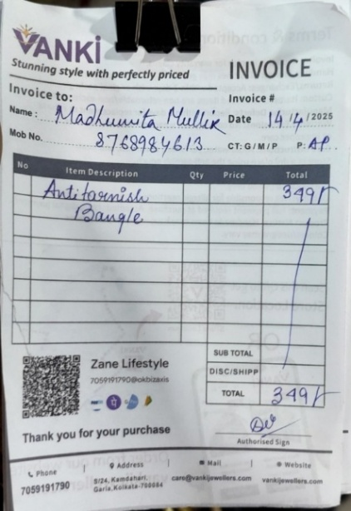
Figure 1: Raw data
The following steps were taken to process this data:

Step 1: Manual Data Entry
Invoices were manually entered into Microsoft Excel on a per-order basis. Each order required entering the following details: order number, date, names of the products, categories, quantities, unit prices, order total, payment mode and whether it was returned or not. This resulted in the creation of the Invoices sheet with 100 entries.

Step 2: Flattening the Data
Since each order may consist of up to 3 different products, the wide form invoices data was flattened to be one row per product form. This resulted in the creation of the Daily Sales sheet with 204 entries, thus making it possible to calculate the income per product using the following formula: Line Total = Qty × Unit Price. A new column, Month (Mar/Apr/May) was also added for filtering purposes.

Step 3: Building the Product Summary
Using SUMIF function and sorting in Excel, all 75 products were summarized into Product Summary sheet with total quantities sold, revenue and cumulative revenue percentage per product. A separate summary at category level was also created. This sheet will be used directly as an input for the ABC classification in the final submission.

Step 4: Data Cleaning
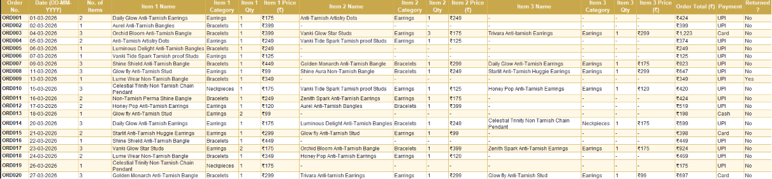
Two returned orders (ORD009 — Lume Wear Non-Tarnish Bangle, and ORD050 — Elegance Unbound Anti-Tarnish Bangle) were marked in the Returned column but kept in the dataset since the transaction was made and the value was recorded. Products with inconsistent naming were standardised.
Figure 2: Invoices entered manually from Raw Data
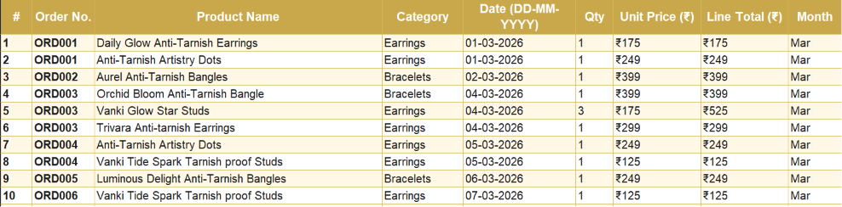
Figure 3: Daily Sales Sheet (Flattened Transaction Data)
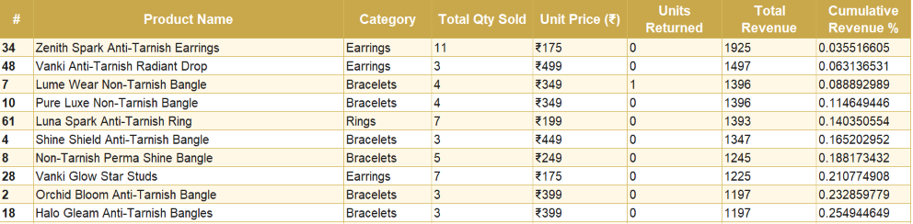
Figure 4: Product Summary Sheet with Cumulative Revenue %

Justification for Descriptive Analysis
Descriptive analysis is more appropriate than the alternatives at this stage for three reasons:
- It matches the data maturity.
This is the first time Zane Lifestyle's sales have been recorded digitally. There is no historical baseline to compare against, which means predictive or diagnostic methods would have no reference point to draw from. Descriptive analysis builds that baseline.
- It directly addresses the business problem.
The owner's core complaint is not knowing which products are selling and which are not. Descriptive statistics (totals, averages, category breakdowns, and monthly trends) answer this directly without requiring complex modelling.
- It supports the next stage.
The descriptive outputs (specifically the Product Summary with cumulative revenue percentages) are the exact inputs required for ABC classification and Pareto analysis, which will form the core of the final submission. Descriptive analysis here is not an end in itself, it is the necessary foundation.
Diagnostic analysis was considered but ruled out for the mid-term because it requires understanding why sales patterns exist (e.g., marketing spend, external events), data for which was not collected. Predictive analysis requires multiple periods of historical data to build a reliable forecast model, which is not yet available. Prescriptive analysis will be applied in the final submission once ABC classification results are available.
Applied to the two objectives in this project, descriptive analysis delivers different outcomes at this stage.
For Objective 1 (Sales and Inventory Performance Analysis), descriptive statistics directly produce Findings 1–4 in this submission; category-level and monthly revenue breakdowns that identify fast- and slow-moving products and the early signs of seasonal demand growth.
For Objective 2 (Unconfirmed Order Hold Management), descriptive analysis has not yet been applied, as hold-specific data is still being collected; this objective will be addressed in the final submission through hold-duration tracking and lost-opportunity-cost estimation, as detailed in the Status of Objective 2 section.

Analysis Tools
All analysis for this project was conducted using Microsoft Excel, for the following reasons:
- The business owner is familiar with Excel, making the final dashboard deliverable immediately usable by them without additional software training.
- Excel's built-in functions (SUMIF, MAX, MIN, AVERAGE, SORT) are sufficient for descriptive statistics and ABC classification at this data scale (100 orders, 75 unique products).
- Charts and pivot tables in Excel allow visual representation of findings that can be directly embedded in the report and shared with the business.
The specific Excel functions used include SUM and SUMIF for revenue aggregation, MAX and MIN for price range identification, COUNT for order frequency, and sorting with cumulative percentage calculation for the Product Summary sheet.

6 Results and Findings
The insights drawn from the descriptive analysis of Zane Lifestyle's three-month transaction data (March–May 2026) are presented below. These findings address Objective 1 (Sales and Inventory Performance Analysis) in full; progress on Objective 2 (Unconfirmed Order Hold Management) is reported separately in the Status of Objective 2 section, as that data is still being collected.

Finding 1: Bracelets and Earrings Dominate Revenue

Figure 5: Total Revenue by Product Category (Mar–May 2026)
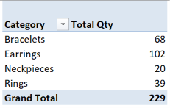
The categorization of revenue reveals that the two main sources of revenue are Bracelets (₹21,850) and Earrings (₹20,343), collectively accounting for 78% of the overall revenue (₹54,200). Rings contribute 14.4% (₹7,793), whereas Neckpieces contribute 7.8% (₹4,214).

It is observed that Earrings are the top-selling product category with the most units sold (102) against Bracelets (68); nevertheless, the revenue generated from Bracelets is slightly higher due to higher average unit price (₹321 for Bracelets vs ₹199 for Earrings). Hence, Earrings have faster velocity as compared to Bracelets which generate more revenue per unit. In case of inventory management, both categories are important in their own way.
Neckpieces form the lowest selling units (20) and lowest revenue generating category (₹4,214). The finding implies that there should be no overstocking of necklaces, and only those models which have proved themselves should be purchased.

Finding 2: Revenue is Growing Strongly Month on Month

Figure 6: Monthly Revenue Trend (March–May 2026)
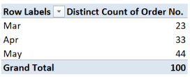
Monthly revenue grew consistently across the three months:
- March: ₹11,106 (23 orders)
- April: ₹16,812 (33 orders): +51.4% over March
- May: ₹26,282 (44 orders): +56.3% over April
This clearly indicates the tendency of growth. The number of orders and average order value (AOV) has grown every month. AOV has increased from ₹482 in March to ₹509 in April and ₹597 in May. In addition to increasing purchases, there was a shift towards more expensive purchases.
A likely explanation for this growth pattern is the Indian wedding season calendar. The March-to-May revenue surge reflects the Bengali wedding season, where peak wedding months drive purchasing not just from brides but also guests buying jewellery and accessories. Since buying behaviour starts one to two months before weddings, this ramp-up in both order volume and average order value represents broad pre-wedding demand across the customer base. The key operational implication: inventory of top-performing products must be built up by February-March at the latest to avoid stockouts during this critical high-revenue window, which is precisely the core business problem the proposal addresses.

Finding 3: A Small Set of Products Drive Most Sales
The top 10 products by revenue are:
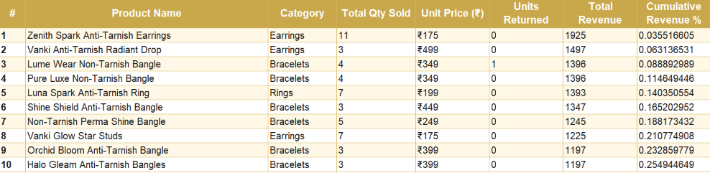
Figure 7: Top 10 Products by Total Revenue
These 10 products out of 75 total SKUs generate ₹13,818 — approximately 25.5% of total revenue. This preliminary pattern supports the Pareto principle (80/20 rule) that will be formally tested through ABC classification in the final submission.
Among all, Zenith Spark Anti-Tarnish Earrings became the best-selling product by the number of sold units with 11 pieces – the largest number among all SKUs. Therefore, this product is considered to be the most rapid mover.

Finding 4: Units Sold by Category Shows Earrings Lead in Volume

Figure 8: Units Sold by Category
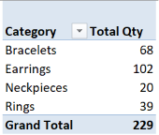
Of the 229 total units sold, Earrings account for 44.5% (102 units), followed by Bracelets at 29.7% (68 units), Rings at 17% (39 units), and Neckpieces at 8.7% (20 units).
It is clear that there is a considerable difference in the number of units in Earrings compared to others. Customers are buying earrings most often, likely because they are lower-priced entry points (average ₹199) that encourage repeat purchases. This has a direct implication for inventory, i.e., the business must always maintain a wide variety of earring options to avoid stockouts in its highest-volume category.

Summary of Key Patterns
The four findings above reveal three clear patterns in Zane Lifestyle's sales data:

Pattern 1: Volume vs Value split
Earrings lead in units; Bracelets lead in revenue. Inventory strategy must account for both dimensions separately.

Pattern 2: Accelerating growth
Revenue nearly doubled from March to May. The business is scaling rapidly, and while seasonal awareness has supported strong sales so far, a more systematic approach to inventory management will be needed to sustain this growth reliably as order volumes continue to rise.

Pattern 3: SKU concentration
A small number of products are doing the heavy lifting. The final submission will formally classify all 75 SKUs into A, B, and C tiers to make this actionable.

Status of Objective 2
Assessing the financial impact of informal stock reservations could not be analysed in this submission because hold-specific data was not part of the original invoice and chat records reviewed in Step 1 (Manual Data Entry). The Invoices and Daily Sales sheets currently capture Payment Mode and Returned? status, but do not record whether an order was placed on hold, for how long, or what value of stock was tied up.
- Data captured so far: Order-level payment mode (UPI, Card, Cash) and return status for all 100 orders, which establishes a baseline of confirmed transactions to compare against.
- Data still required: (1) number of orders placed on hold without payment confirmation, (2) duration each hold was active, (3) value of inventory blocked per hold, and (4) any resulting lost sales where the held stock was unavailable to other buyers.
- Plan to close the gap: Another meeting has been arranged with the Zane Lifestyle owner to gather this data from the WhatsApp chats where the informal holds were being recorded using the conversations. This data will be digitalised in a fourth sheet (Hold Tracker) and analysed in the final submission using hold duration calculation and lost opportunity cost evaluation as proposed in Section 5.1 of the original proposal.

Note on Additional Business Need Raised by Owner
A request has been raised by the owner during the second meeting with Zane Lifestyle owner (recording shared in Section 2) to examine ways to improve the performance of the business in terms of marketing. This request was made after the proposal stage, and no marketing-related data (e.g., social media engagement, ad spend, campaign performance, follower growth) was made available at the time of this submission.
Since the additional request is beyond the two objectives approved at the proposal stage (Sales and Inventory Performance Analysis, and Unconfirmed Order Holds Management), this requirement cannot be incorporated in the project as an additional objective. However, since the inventory and sales velocity analysis in this submission show which products and categories perform well, these results can lead to a marketing recommendation in the Interpretation of Results and Recommendation part of the final submission.

